Lab 4 using your specific repository, layout, and networking assumptions. This version treats Local subnets as private networks and treats the remote server / inter-site network as a 10.10.x.x “internet/public network” for the purposes of NAT and routing logic. It also assumes the repository hierarchy:

automation/
├── mockup-infra/
└── week02-stateless-stateful/
└── phase1-mockup/

We will produce:
✅ A revised high-fidelity lab plan ✅ Detailed addressing & topologies ✅ Cisco-themed network section ✅ IaC / VS Code section ✅ Troubleshooting and engineering reflection ✅ A complete README.md ready to be committed to the repo

- นายพัชรพล กองแก้ว 673380415-5 Sec 4
- นายกฤษฎา นามมนต์เทียน 673380388-2 Sec 4
- นายวงศธร ธน.ยอด 673380425-2 Sec 4
- นายปรีชา ศรีหนองบัว 653380335-1 Sec4
- นายศุภกิตติ์ ฟันเฟือย 673380427-8 Sec 4
- นายดรัณภพ สุริเตอร์ 673380402-4 Sec 4

🧪 LAB 4 Simulated Internet (10.10.0.0/16) & Private LANs with Stateful vs Stateless Services

🎯 LAB GOALS
- Network Setup: Create two local labs (A & B) connected via a simulated “public/internet” network (10.10.0.0/16)
- NAT + Routing: Configure static routes and NAT so local traffic reaches remote services
- Application Deployment: Use mockup-infra from your repository to deploy stateless and stateful APIs
- Testing: Compare how sessions behave locally vs across the simulated internet

👥 TEAM BREAKDOWN (5–6 students)
Role | Count | Focus
Network Architects | 2 | Router configs, Cisco CLI
IaC/DevOps | 2 | VS Code, mockup-infra
QA/Test | 1–2 | Server/Client scripting, session behavior

🗺️ UPDATED NETWORK TOPOLOGY
 10.10.12.0/30 “Public/Internet”
┌─────────────────────────┐
│ │
R1-G0/0 (10.10.12.1) R2-G0/0 (10.10.12.2)
│ │
Private LAN A (192.168.10.0/24) Private LAN B (192.168.20.0/24)
│ │
SwitchA SwitchB
│ │
ServerA (mockup) ServerB (mockup)
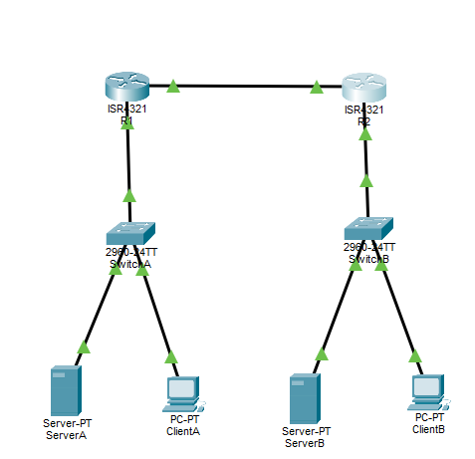
ClientA ClientB

We treat 10.10.12.0/30 as a simulated internet for the purposes of NAT + public reachability.
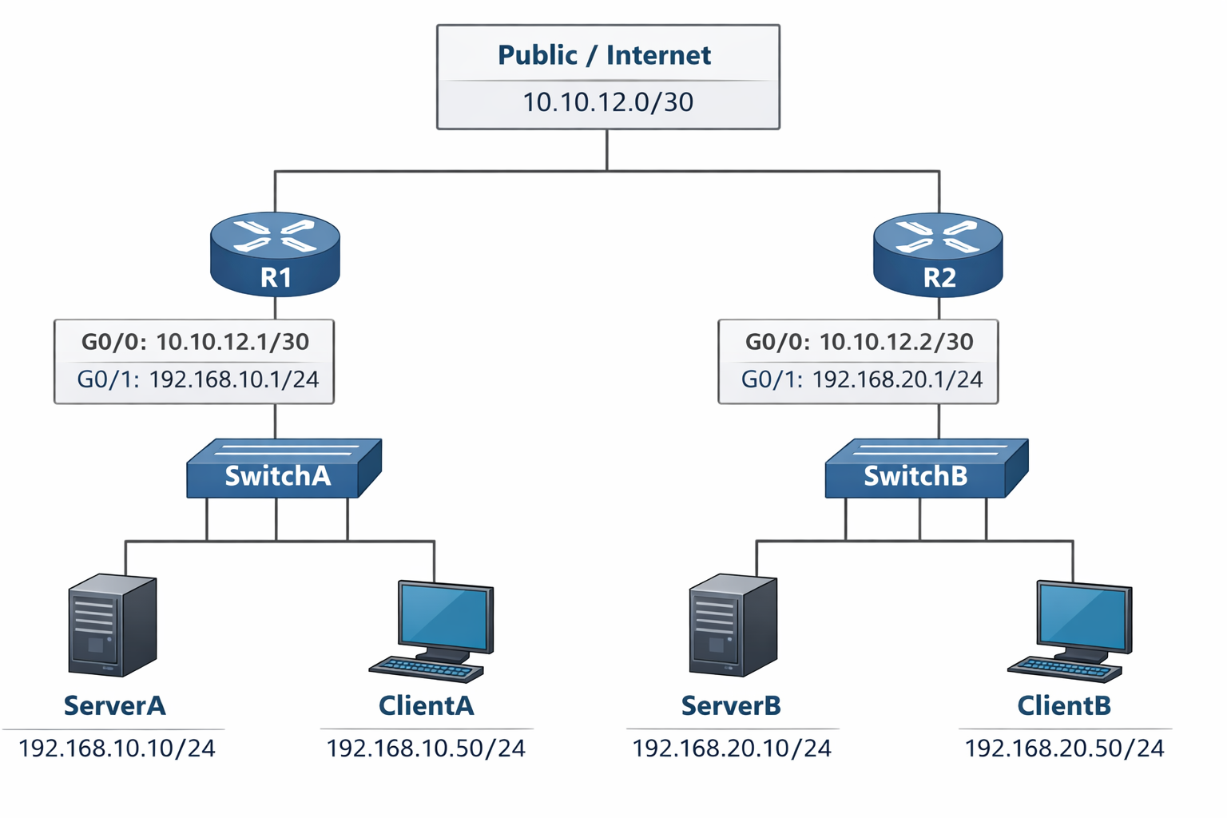

📍 ADDRESS TABLE
Component | Interface | IP | Mask | Role
R1 | G0/0 | 10.10.12.1 | /30 | Public
R1 | G0/1 | 192.168.10.1 | /24 | LAN A Gateway
ServerA | eth0 | 192.168.10.10 | /24 | Mockup infra A
ClientA | eth0 | 192.168.10.50 | /24 | Tester
R2 | G0/0 | 10.10.12.2 | /30 | Public
R2 | G0/1 | 192.168.20.1 | /24 | LAN B Gateway
ServerB | eth0 | 192.168.20.10 | /24 | Mockup infra B
ClientB | eth0 | 192.168.20.50 | /24 | Tester

🔧 PART 1 — CISCO-STYLE NETWORK CONFIGURATION
We will configure static routing + NAT to allow cross-site reachability.

🧱 R1 CONFIGURATION (LAN A)
enable
conf t

hostname R1

interface g0/0
ip address 10.10.12.1 255.255.255.252
ip nat outside
no shutdown

interface g0/1
ip address 192.168.10.1 255.255.255.0
ip nat inside
no shutdown

ip route 192.168.20.0 255.255.255.0 10.10.12.2

access-list 10 permit 192.168.10.0 0.0.0.255
ip nat inside source list 10 interface g0/0 overload

end
write memory


🧱 R2 CONFIGURATION (LAN B)
enable
conf t

hostname R2

interface g0/0
ip address 10.10.12.2 255.255.255.252
ip nat outside
no shutdown

interface g0/1
ip address 192.168.20.1 255.255.255.0
ip nat inside
no shutdown

ip route 192.168.10.0 255.255.255.0 10.10.12.1

access-list 10 permit 192.168.20.0 0.0.0.255
ip nat inside source list 10 interface g0/0 overload

end
write memory


🧪 ROUTING & NAT VERIFICATION
On R1 & R2:

show ip route
show ip nat translations
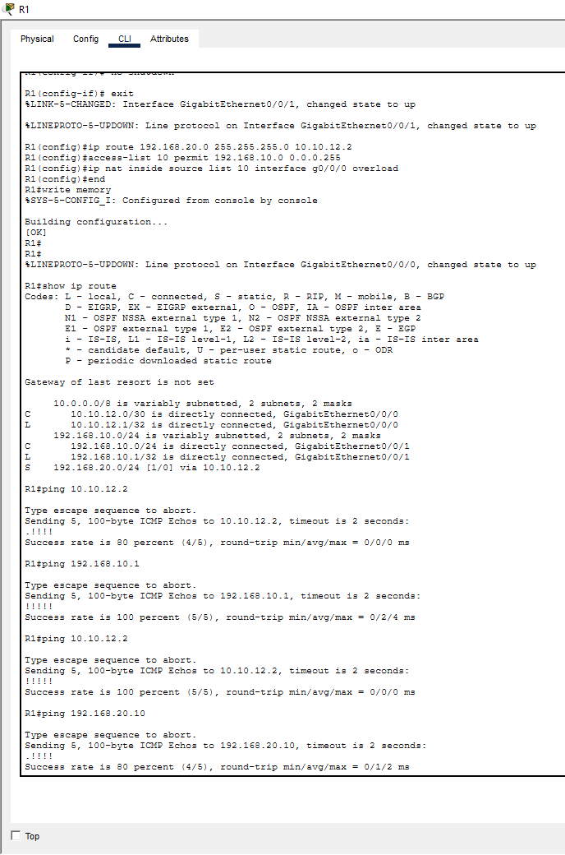
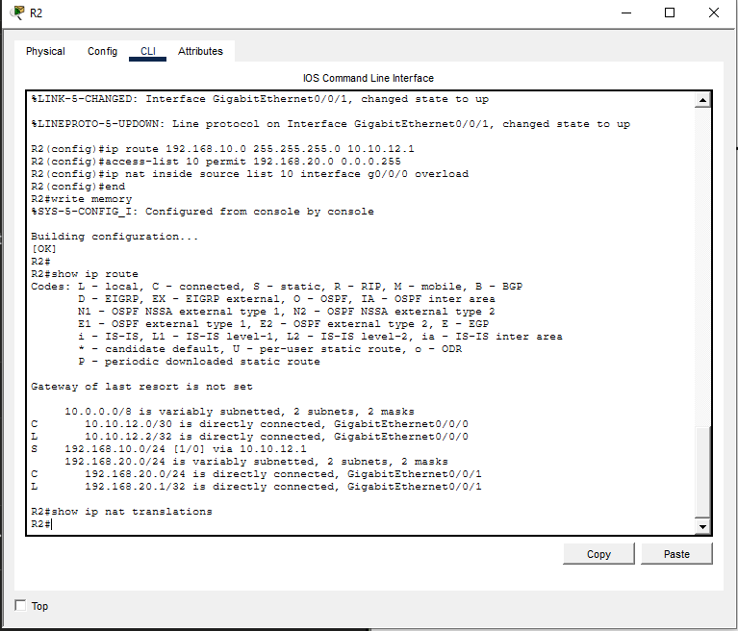
From ClientA:

ping 192.168.20.10 ← Remote server reachable
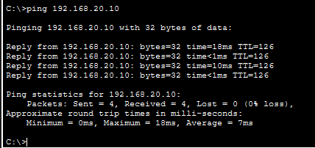

💻 PART 2 — IaC + MOCKUP-INFRA DEPLOYMENT (mockup-infra/README.md)
We will now set up mockup infra using the paths you specified:

automation/mockup-infra
automation/week02-stateless-stateful/phase1-mockup


🛠 CLONE REPOปรีชา ศรีหนองบัว
git clone https://github.com/boonsup/automation.git
cd automation


🧰 VS CODE — OPEN PROJECT
In VS Code, open the automation folder.

📄 CREATE SERVER-SPECIFIC ENV FILES

ServerA (ServerA.env)
# Private LAN A
PUBLIC_NET_SUBNET=192.168.10.0/24
HOST_IP=192.168.10.10
REMOTE_NET_PUBLIC=10.10.12.0/30

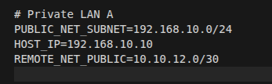

ServerB (ServerB.env)
# Private LAN B
PUBLIC_NET_SUBNET=192.168.20.0/24
HOST_IP=192.168.20.10
REMOTE_NET_PUBLIC=10.10.12.0/30
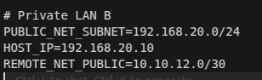

🚀 DEPLOY MOCKUP-INFRA

PowerShell (Windows Admin)
cd mockup-infra
python manage.py init
python manage.py deploy --profile week02-stateless-stateful

Bash (Linux)
cd mockup-infra
chmod +x scripts/*.sh
./scripts/init-env.sh
python manage.py deploy --profile week02-stateless-stateful

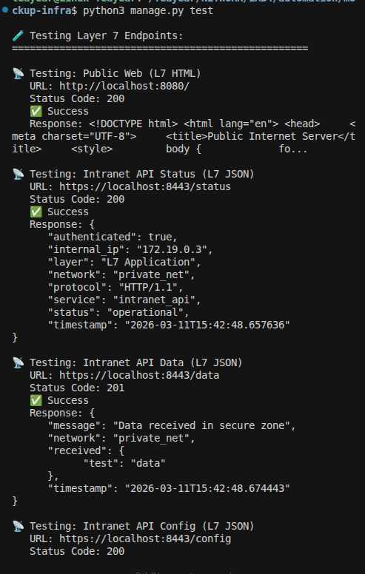

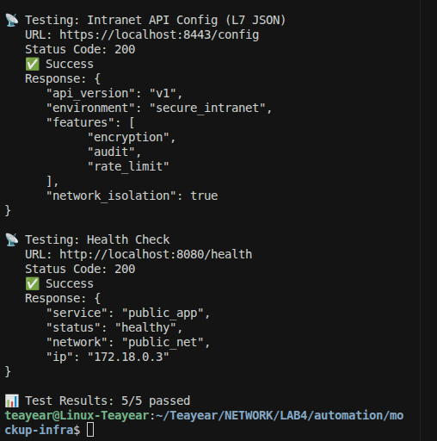

🟡 VERIFY CONTAINERS
podman ps

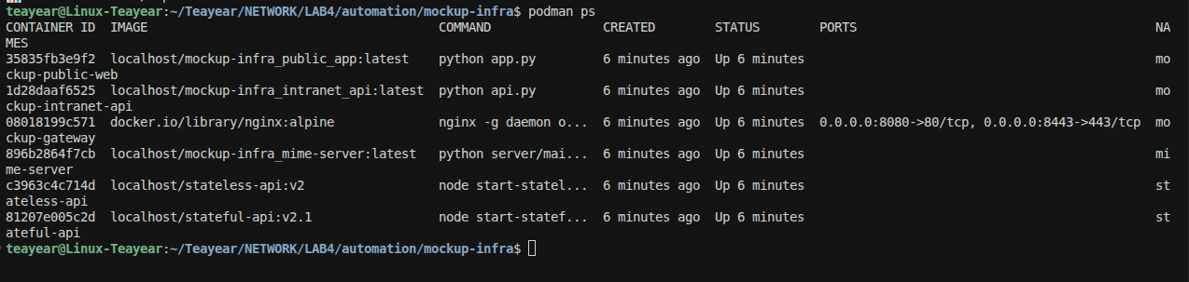

Should show:

Container | Port
stateless-api | 3000
stateful-api | 3001

🧪 PART 3 — TESTING STATELESS vs STATEFUL (week03-stateless-stateful/phase1-mockup/README.md)

⚫ LOCAL TESTS (Private LAN)
From ClientA:

curl http://192.168.10.10:3000/info

→ Stateless
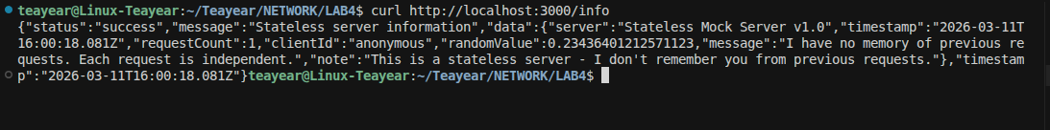

From ClientA:

curl -X POST http://192.168.10.10:3001/session


Store the returned Session-ID, then:

curl http://192.168.10.10:3001/data -H "Session-ID: <id>"


🔵 REMOTE TESTS (Via Simulated Internet)
From ClientA:

curl http://10.10.12.2:3000/info

That will target ServerB stateless — NAT + routing should deliver

Session Test:

curl -X POST http://10.10.12.2:3001/session

→ ServerB returns a session ID

Then:

curl http://10.10.12.2:3001/data -H "Session-ID: <id>"

Check session persists across NAT

⚠️ TROUBLESHOOTING

❗ Cannot Reach Remote
- Gateway misconfiguration
- NAT ACL incorrect
- Wrong default gateway on clients

Check:

show ip route
ping 10.10.12.2 from R1

❗ Sessions Lose State
- Missing header
- Wrong container port
- Firewall blocking port 3001

🧠 ENGINEERING REFLECTION
- Stateless services don’t depend on prior data
- Stateful services require session headers
- NAT shouldn’t affect logical session identity

📄 LAB README.md (for repository)
# Lab 4 — Stateful vs Stateless Across Public & Private Subnets

## Architecture
Two LANs connected via a simulated internet (10.10.12.0/30)
- LAN A: 192.168.10.0/24
- LAN B: 192.168.20.0/24
Routers provide static routing + NAT.

## Steps

### 1. Setup Network
Configure R1 and R2:
- Static routes
- NAT overload
- Verify ping

### 2. Deploy IaC
Configure `ServerA.env` and `ServerB.env`
Deploy via VS Code, PowerShell or Bash using:

python manage.py deploy --profile week02-stateless-stateful


### 3. Validate
- Local stateless vs stateful
- Remote stateless vs stateful
- Test session persistence
- Capture NAT translations

## Troubleshooting
- Check interface status, NAT ACLs
- Verify client gateways

## Extensions
- OSPF instead of static routing
- Load balancer in front of APIs


